Effects Of Long Term Power Outages
November 4, 2012, by Ken Jorgustin
0
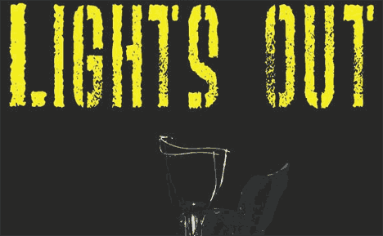
The effects of long term power outages will be very severe to our modern way of life. Our human civilization has only existed with the ‘help’ of electricity for a VERY small slice of its overall timeline. It, and other factors, have enabled enormous population growth on the planet… to the point where if it were not for electricity, a large percentage of us would cease to exist.
A worst case scenario would likely doom 90% of us, more or less. Imagine (if you dare) some of the following effects…

Computers, radios, televisions and phones will stop functioning… modern communication ceases for the most part.
Banks close, money systems fail, no more ATM.
Complete economic collapse.
Gas stations stop functioning and most transportation ceases.
Food distribution systems cease.
Food is no longer available in stores.
No ability to cook with electric appliances.
No ability to refrigerate food for most people.
Toilets, sinks, and showers do not operate from lack of municipal water pressure.
No safe drinking water without treatment.
No furnace heat.
No air conditioning cool.
Hospitals close (in the modern sense) and modern medical care ceases to exist.
Emergency response (Police, Fire, Ambulance) will cease.
Social Chaos and desperate violence.
LIGHTS OUT

We have recently witnessed a microcosm of some of the effects of power outage and grid down, and some of the things that go along with it, from events like hurricane Katrina and hurricane Sandy.
Now picture this, but on a national scale. It is nearly unimaginable. But… the thing is… it could happen. The weapons exist today, and it is not terribly difficult (a relative term) to pull it off with a Scud missile and a nuclear weapon.
Our Sun could easily unleash a solar flare of sufficient magnitude (X-20+) which would accomplish the same devastating effects. In fact, it already did so back in 1859 – except we were not dependent upon electricity back then.
We can go on ‘hoping’ or believing that something like this will never happen to us, or we can use the worst case scenario to highlight the areas in which we can better prepare. Weaning yourself off the systems of dependency (or at least some of them) will give you a fighting chance. Not only that, but greater self-sufficiency will reward you with a surprising amount of peacefulness and liberation. Try it… you’ll see…

